**PROJECT REPORT**

**ON**

**Desktop Notifier App**



REPORT SUBMITTED

TO

VISHWAKARMA INSTITUTE OF INFORMATION TECHNOLOGY, PUNE

FOR THE PBLOF FUNDAMENTALS OF PROGRAMMING

IN

**ENGINEERING AND APPLIED SCIENCE DEPARTMENT**

BY

|  |  |  |
| --- | --- | --- |
| Name | Roll no | PRN |
| Tanmay Mirashi | **9041** | **22010676** |
| Mrunal Hedau | **9042** | **22010692** |
| Gaurav Kanade | **9043** | **22010708** |
| Sanket Sonawane | **9044** | **22010724** |
| Manaswi Jokhare | **9045** | **22010740** |
| Shreya Yele | **9046** | **22010756** |
| Shubham Anawade | **9047** | **22010772** |

**Class: Btech Division: I Batch:I2**

**Batch Teacher**

**Mr. Anup W. Ingle**

**INDEX**

|  |  |  |
| --- | --- | --- |
| **Sr. No.** | **Contents** | **Page No.** |
| **1** | **ABSTRACT** | **1** |
| **2** | **Introduction and Theory** | **2** |
| **3** | **FLOW of Program** | **3** |
| **4** | **source code of the program** | **4** |
| **5** | **output** | **5** |
| **6** | **LIST OF THE TOPICS/ CONCEPT WHICH ARE COVERED FROM THE SYLLABUS** | **9** |
| **7** | **LIST OF THE TOPICS/ CONCEPT WHICH ARE OUT OF SYLLABUS** | **10** |
| **8** | **CONCLUSION** | **11** |
| **9** | **REFERENCES** | **12** |

**ABSTRACT:**

Desktop Notifier Project is basically designed to notify the user about various things going on in the world. In this project we have included various kinds of notifications like: Live corona updates, Random notifications that give

positive quotes and thoughts to make the day better and motivate the user, the notifications also display certain Jokes to lighten the mood and Take a break notifications to inform the user to take a short break from the technology that may help the user to relax his/her eyes, Health tips notifications for the user to know more about his or her body and provide more information to live a healthy life. The project generates random notifications on the Desktop when the user is using his/her Laptop or Desktop. It uses various Python libraries and modules to fetch data from the web and the already existing files in the device and generate the notification in the notification bar. The details have been explained in this report.

**Introduction and Theory:**

**In this project we are creating a desktop notifier which shows alert as well as necessary thing which we need like health tips, positive thoughts, corona live update and take a break notification after every 1hr(60min). In this project Tanmay had made health tips, Gaurav has made jokes notification, Sanket has made valuable quote of great Indian people, Shubham has made a thought notifier, Shreya has made corona live tracker which shows daily update about how much cases are active and how much of them has recovered form covid-19, Mrunal and Manaswi has made GUI window and to operate it buttons have been made.**

**To make this project we have get various python module like plyer, time, bs4, win10toast, pyjokes, random, tkinter modules have been used to make a desktop notifier app/project.**

**FLOW of Program:**

On opening the application,

A GUI window appears in order to get user input.

Six options are given to the user.

End

**source code of the program:**

import time

from plyer import notification

if __name__=="__main__":

    notification.notify(

        title = "Please Drink A water",

        message = "****Take a Break!!!!",

        app_icon = "C:\\Users\\Dell\\OneDrive\\Desktop\\project PE\\ICO\\istockphoto-902228542-612x612.ico",

        timeout = 10

    )

    time.sleep(60*60)

This is the code for simple notification which we made by importing time and from plyer we have import notification to have notification which we are have to provide to user.

This is a simple code for taking a break after every 1hour(60min).In this notification the pop up occurs when we run the program and the title which we shown is **“Please Drink A Water”.** And the message we shown is **“****Take A break!!!!”** We have also added app icon to it to look pretty good to see. The pop up is only display for 10 sec only. Because we don’t want to show notification for much longer time so we kept it just for 10 sec.

**output:**

Take a break output: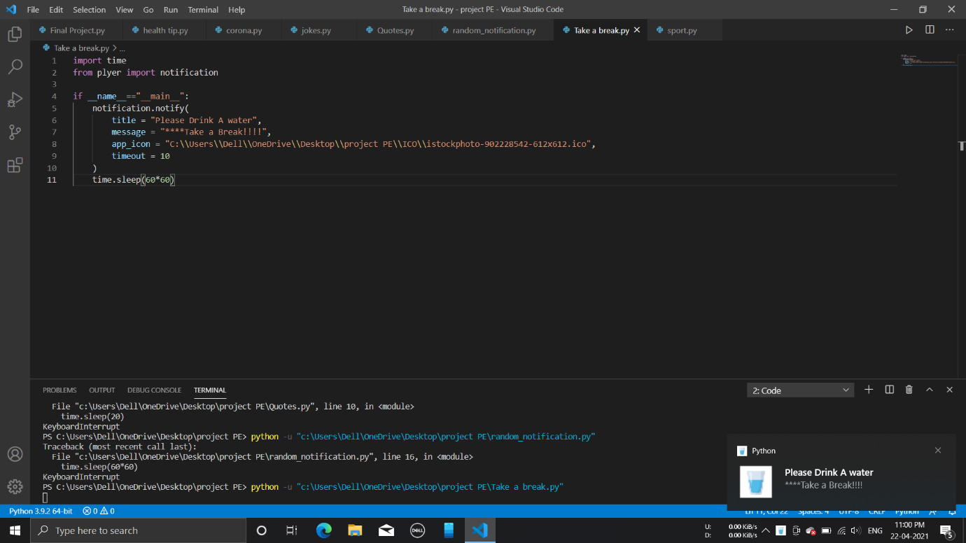

Random Notification output: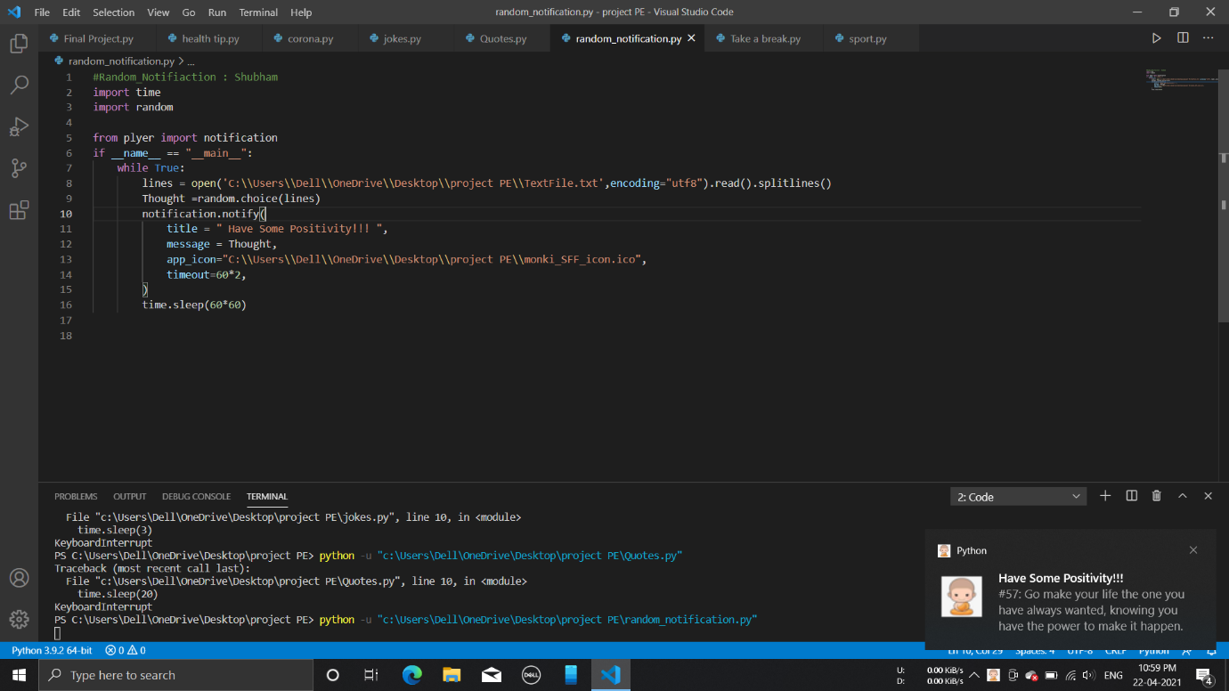

Quotes Notification: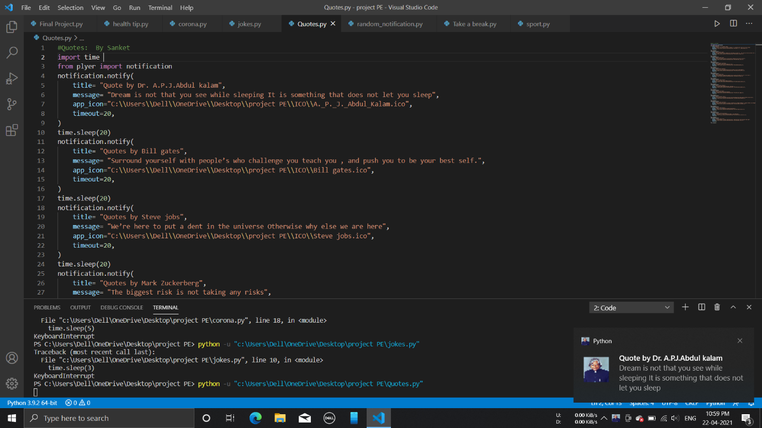

Jokes Notification: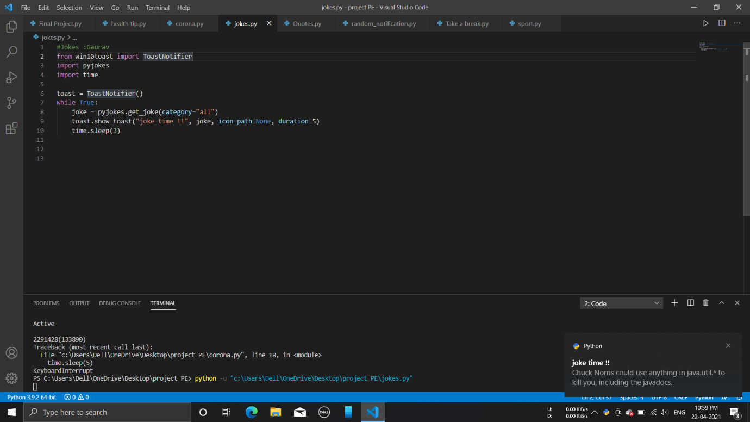

Covid Live update Notifiaction: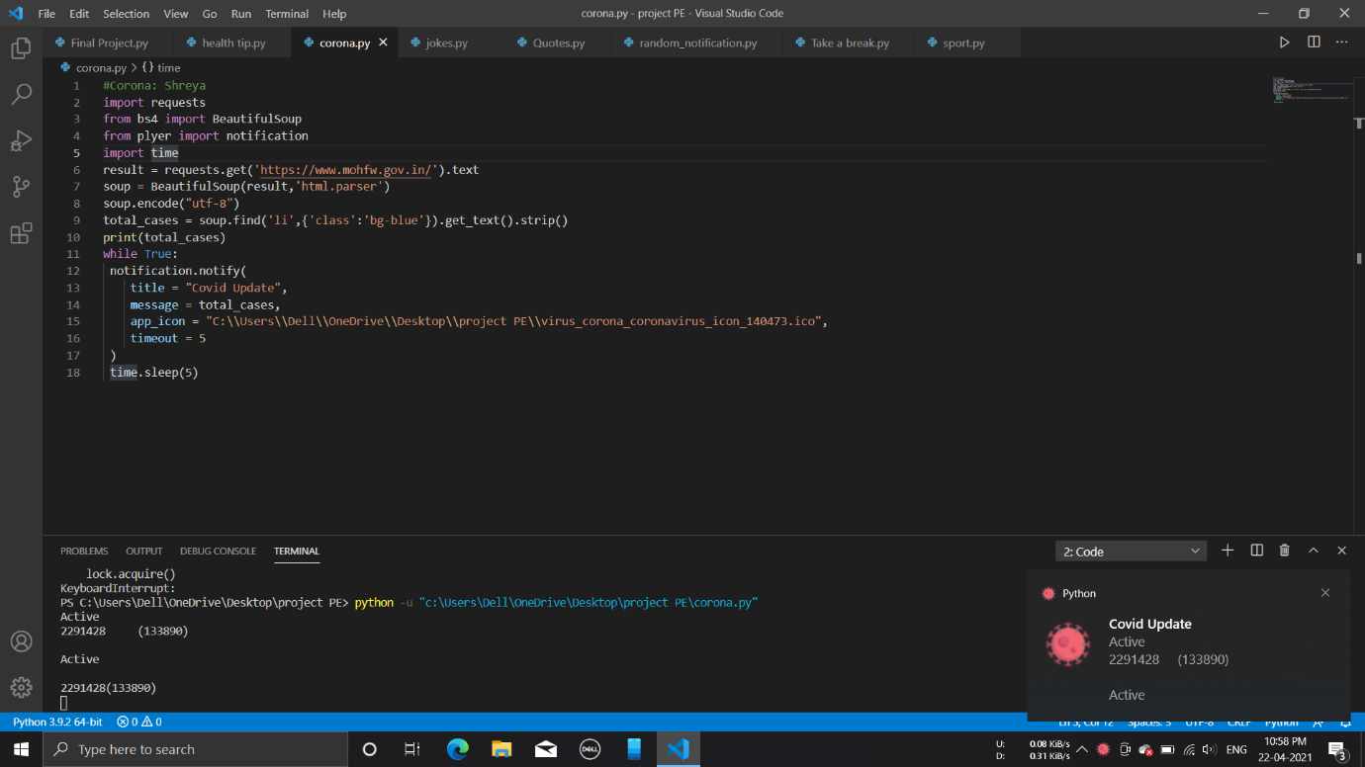Health Notifier Output: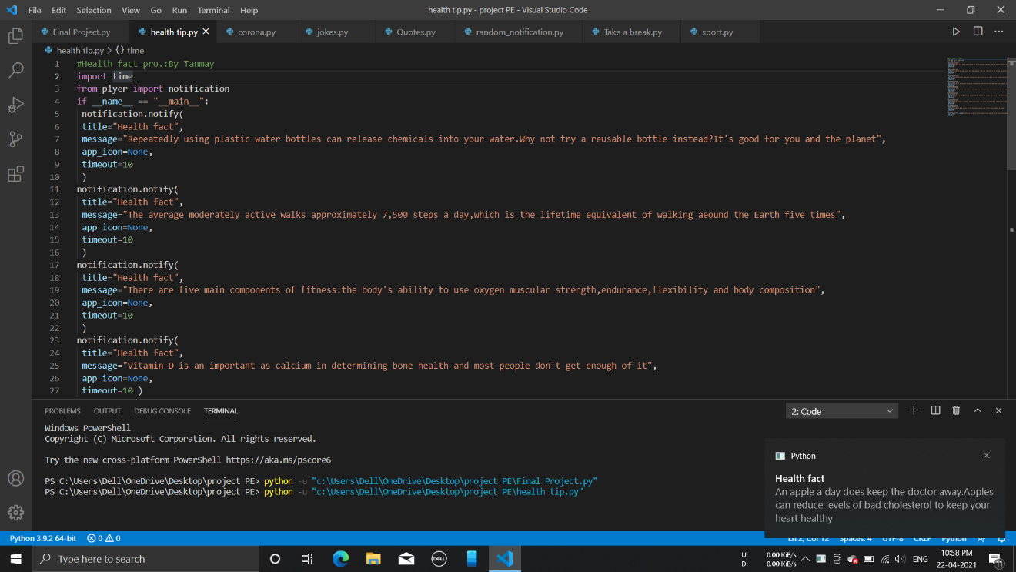GUI Window: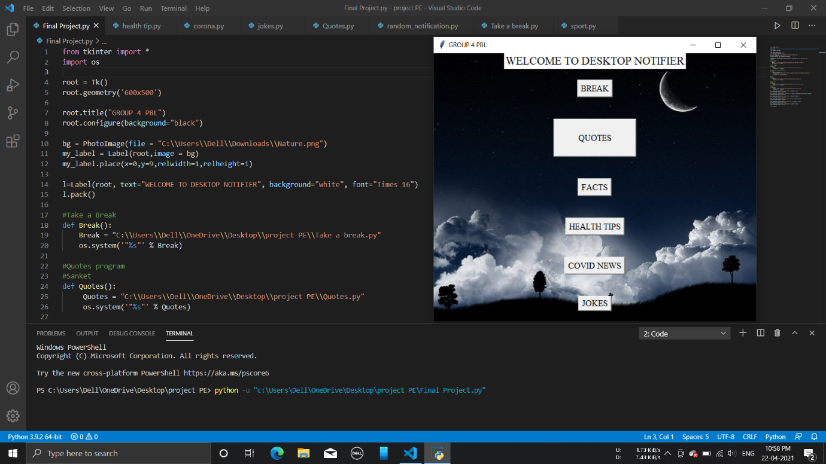

**LIST OF THE TOPICS/ CONCEPT WHICH ARE COVERED FROM THE SYLLABUS:**

1.How to use while loop

2.How to use user define functions

3.How to initiate variable

4.Import os

5.Import time

6.How to add path file

**LIST OF THE TOPICS/ CONCEPT WHICH ARE OUT OF SYLLABUS:**

1.How to use different type of library's

2.How to use function code with respected module code

3.How to get data from website

4.How to particular data from website

5.How to get data from website which are encoded in different language

6.How to get data in form of notification

7.How to display notification after some time intervals

8.How to add different parameter in function code

9.How to add icon

10.How to requests website to get data

11.Tkinter module

12.How to create button

13.How to create GUI window

14.Various python packages we have used

**CONCLUSION:**

Thus, the desktop notifier project was created which gives random notifications to the user while using their device

**REFERENCES:**

* <https://youtu.be/BSfbjrqIw20>
* <https://youtu.be/yuuDJ3-EdNQ>
* <https://www.youtube.com/watch?v=VMP1oQOxfM0>
* <https://www.youtube.com/watch?v=yQSEXcf6s2I>
* <https://www.youtube.com/watch?v=h_0lPh7LE_E>
* <https://www.youtube.com/watch?v=HHddgUtliBg>
* <https://youtu.be/Hh_oqNibhvo>
* <https://youtu.be/y2IhT3L33-Y>